1-Ip

What is an IP?
# Source: AI Source: Provided by: [Data Path: Persons Table -> ID Column: 1, Name_En Column: Motasem Essam] -> From: [ChatGPT] on [1/18/2026]
IP stands for Internet Protocol.

Simple Definition:
# Source: AI Source: Provided by: [Data Path: Persons Table -> ID Column: 1, Name_En Column: Motasem Essam] -> From: [ChatGPT] on [1/18/2026]
An IP is a set of rules that governs how data is sent and received over the internet or any network.

But usually, when people say "IP," they mean: IP Address
# Source: AI Source: Provided by: [Data Path: Persons Table -> ID Column: 1, Name_En Column: Motasem Essam] -> From: [ChatGPT] on [1/18/2026]
- A unique numeric label assigned to each device connected to a network that uses the Internet Protocol for communication.
- Think of it as a device’s address on the internet or network.

Types of IP Addresses:
# Source: AI Source: Provided by: [Data Path: Persons Table -> ID Column: 1, Name_En Column: Motasem Essam] -> From: [ChatGPT] on [1/18/2026]
- IPv4 — The most common format (e.g., 192.168.1.1)
- IPv6 — Newer format to support more devices (e.g., 2001:0db8:85a3:0000:0000:8a2e:0370:7334)

What Does an IP Address Do?
# Source: AI Source: Provided by: [Data Path: Persons Table -> ID Column: 1, Name_En Column: Motasem Essam] -> From: [ChatGPT] on [1/18/2026]
- Identifies a device on a network.
- Helps route data from one device to another.

IPv4 vs IPv6 Image
# Source: Table Source: Provided by: [Data Path: Persons Table -> ID Column: 1, Name_En Column: Motasem Essam] From: [Data Path: Miscellaneous Folder -> Miscellaneous Database -> Miscellaneous Table -> ID: 25] on [1/18/2026]
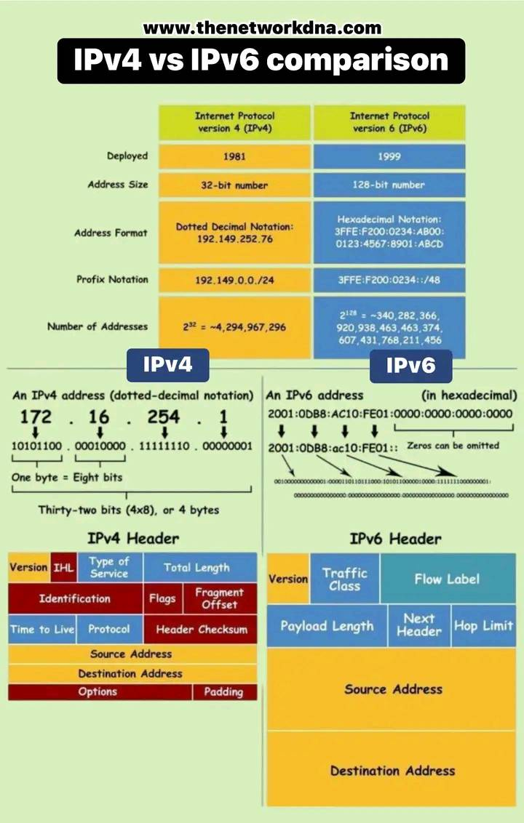

Summary
# Source: AI Source: Provided by: [Data Path: Persons Table -> ID Column: 1, Name_En Column: Motasem Essam] -> From: [ChatGPT] on [1/18/2026]
An IP address is like a digital home address that helps devices find and communicate with each other on a network or the internet.

2-TCP

What is TCP (Transmission Control Protocol)?
# Source: AI Source: Provided by: [Data Path: Persons Table -> ID Column: 1, Name_En Column: Motasem Essam] -> From: [ChatGPT] on [1/18/2026]
TCP is a communication protocol that ensures reliable, ordered, and error-free transmission of data between computers over a network.

Key Points about TCP:
# Source: AI Source: Provided by: [Data Path: Persons Table -> ID Column: 1, Name_En Column: Motasem Essam] -> From: [ChatGPT] on [1/18/2026]
- Works on top of IP (Internet Protocol) to deliver data.
- Establishes a connection between sender and receiver before data transfer (called a handshake).
- Splits data into packets, sends them, and makes sure all packets arrive correctly and in order.
- If packets are lost or corrupted, TCP retransmits them.
- Used for applications where accuracy matters, such as:
  - Web browsing (HTTP/HTTPS)
  - Email (SMTP, IMAP)
  - File transfers (FTP)

Handshake
# Source: AI Source: Provided by: [Data Path: Persons Table -> ID Column: 1, Name_En Column: Motasem Essam] -> From: [ChatGPT] on [1/18/2026]
A handshake is the process by which two devices establish a connection and agree on how to communicate before actually exchanging data.

In Other Words:
# Source: AI Source: Provided by: [Data Path: Persons Table -> ID Column: 1, Name_En Column: Motasem Essam] -> From: [ChatGPT] on [1/18/2026]
It’s like saying:
“Hi, are you there?”
“Yes, I’m here — ready to talk.”
“Okay, let’s begin.”
This ensures both sides are synchronized and ready to communicate reliably.

what is types of handshakes

1. Three-Way Handshake (TCP)
# Source: AI Source: Provided by: [Data Path: Persons Table -> ID Column: 1, Name_En Column: Motasem Essam] -> From: [ChatGPT] on [1/18/2026]
- Used by: TCP (Transmission Control Protocol)
- Steps: SYN → SYN-ACK → ACK
- Purpose: Establish a reliable connection between client and server
- ✅ Most common handshake in networking.

2. Four-Way Handshake (WPA/WPA2 Wi-Fi Security)
# Source: AI Source: Provided by: [Data Path: Persons Table -> ID Column: 1, Name_En Column: Motasem Essam] -> From: [ChatGPT] on [1/18/2026]
- Used by: Wi-Fi networks (WPA/WPA2)
- Steps: 4-message exchange between client and access point
- Purpose: Securely generate and exchange encryption keys for protected wireless communication
- 🔐 Used to protect Wi-Fi with encryption (e.g., WPA2-PSK)

3. SSL/TLS Handshake (HTTPS)
# Source: AI Source: Provided by: [Data Path: Persons Table -> ID Column: 1, Name_En Column: Motasem Essam] -> From: [ChatGPT] on [1/18/2026]
- Used by: Secure web traffic (HTTPS, email, etc.)
- Steps: Varies (can be 2–12+ messages)
- Purpose:
  - Authenticate server (and optionally client)
  - Negotiate encryption settings
  - Exchange encryption keys securely
- 🔐 Ensures secure communication over the web

4. Two-Way Handshake
# Source: AI Source: Provided by: [Data Path: Persons Table -> ID Column: 1, Name_En Column: Motasem Essam] -> From: [ChatGPT] on [1/18/2026]
- Used in: Simpler protocols or hardware-level communication
- Steps: Request → Acknowledge
- Purpose: Basic acknowledgment without full connection establishment
- 🚫 Not as reliable as TCP’s 3-way handshake

5. Zero-RTT Handshake (TLS 1.3)
# Source: AI Source: Provided by: [Data Path: Persons Table -> ID Column: 1, Name_En Column: Motasem Essam] -> From: [ChatGPT] on [1/18/2026]
- Used by: TLS 1.3 (for HTTPS)
- Steps: Data is sent along with the first handshake message
- Purpose: Improve performance by reducing latency
- 🚀 Faster but has trade-offs in replay protection

Summary Table:
# Source: AI Source: Provided by: [Data Path: Persons Table -> ID Column: 1, Name_En Column: Motasem Essam] -> From: [ChatGPT] on [1/18/2026]

Handshake Type | Used By | Purpose
Three-Way | TCP | Reliable connection setup
Four-Way | WPA/WPA2 (Wi-Fi) | Key exchange for encryption
SSL/TLS | HTTPS, Email | Secure authentication & encryption
Two-Way | Simple protocols | Basic acknowledgment
Zero-RTT | TLS 1.3 | Speed up secure connections

Summary
# Source: AI Source: Provided by: [Data Path: Persons Table -> ID Column: 1, Name_En Column: Motasem Essam] -> From: [ChatGPT] on [1/18/2026]
A handshake is the setup phase of communication.
Different protocols (like TCP, TLS, WPA2) use different types of handshakes depending on security, reliability, or speed requirements.

Example: TCP Three-Way Handshake
# Source: AI Source: Provided by: [Data Path: Persons Table -> ID Column: 1, Name_En Column: Motasem Essam] -> From: [ChatGPT] on [1/18/2026]
Used to set up a TCP connection:
- SYN — Client says “I want to connect”
- SYN-ACK — Server replies “Okay, I accept — ready?”
- ACK — Client confirms “Thanks, let’s go!”
After this, data can flow reliably.

Why Is a Handshake Important?
# Source: AI Source: Provided by: [Data Path: Persons Table -> ID Column: 1, Name_En Column: Motasem Essam] -> From: [ChatGPT] on [1/18/2026]
- Confirms both devices are online and listening
- Helps negotiate communication settings
- Can prevent errors or attacks (e.g., in HTTPS)
- Used in security protocols (SSL/TLS handshakes)

Summary
# Source: AI Source: Provided by: [Data Path: Persons Table -> ID Column: 1, Name_En Column: Motasem Essam] -> From: [ChatGPT] on [1/18/2026]
A handshake is the first step in communication — it ensures both sides are ready, before real data is exchanged.

Three-Way Handshake?

🔁 What Is a Three-Way Handshake?
# Source: AI Source: Provided by: [Data Path: Persons Table -> ID Column: 1, Name_En Column: Motasem Essam] -> From: [ChatGPT] on [1/18/2026]
the Three-Way Handshake is a type of handshake — specifically used by the TCP (Transmission Control Protocol).
The three-way handshake is the process used by TCP (Transmission Control Protocol) to establish a reliable connection between two devices before data is exchanged.

📶 Why It's Needed:
# Source: AI Source: Provided by: [Data Path: Persons Table -> ID Column: 1, Name_En Column: Motasem Essam] -> From: [ChatGPT] on [1/18/2026]
TCP is connection-oriented, so it requires both devices (client and server) to agree they’re ready to communicate.
This ensures:
- Both sides are online
- They agree on initial settings (like sequence numbers)
- They can safely start data transmission

🧩 Steps of the Three-Way Handshake:
# Source: AI Source: Provided by: [Data Path: Persons Table -> ID Column: 1, Name_En Column: Motasem Essam] -> From: [ChatGPT] on [1/18/2026]
- SYN (Synchronize)
→ The client sends a packet to the server saying:
"Hey, I want to start a connection. Here’s my initial sequence number."
- SYN-ACK (Synchronize + Acknowledge)
→ The server replies:
"Got it. I accept. Here’s my own sequence number, and I acknowledge yours."
- ACK (Acknowledge)
→ The client responds:
"Thanks! I acknowledge your sequence number. Let’s begin!"
🎉 Now the connection is established, and data can flow!

💡 Visual Summary:
# Source: AI Source: Provided by: [Data Path: Persons Table -> ID Column: 1, Name_En Column: Motasem Essam] -> From: [ChatGPT] on [1/18/2026]
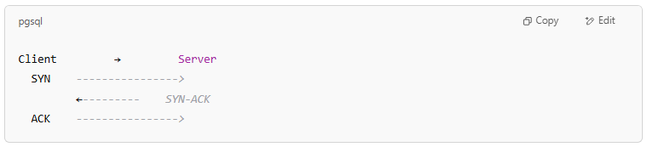
Client → Server
SYN ---------------->
←--------- SYN-ACK
ACK ---------------->

Summary
# Source: AI Source: Provided by: [Data Path: Persons Table -> ID Column: 1, Name_En Column: Motasem Essam] -> From: [ChatGPT] on [1/18/2026]

The three-way handshake is how TCP sets up a connection to ensure both devices are ready and agree on how to exchange data reliably.

How TCP Works (Brief Overview):
# Source: AI Source: Provided by: [Data Path: Persons Table -> ID Column: 1, Name_En Column: Motasem Essam] -> From: [ChatGPT] on [1/18/2026]
- Connection Establishment: Uses a “three-way handshake” to set up a connection.
- Data Transfer: Sends data in packets, tracks which packets are received.
- Acknowledgments: Receiver sends back ACKs to confirm receipt.
- Retransmission: Lost packets are resent.
- Connection Termination: Gracefully closes the connection after data transfer.

Analogy:
# Source: AI Source: Provided by: [Data Path: Persons Table -> ID Column: 1, Name_En Column: Motasem Essam] -> From: [ChatGPT] on [1/18/2026]
TCP is like a phone call where both parties confirm they hear each other clearly and repeat information if needed.

Summary
# Source: AI Source: Provided by: [Data Path: Persons Table -> ID Column: 1, Name_En Column: Motasem Essam] -> From: [ChatGPT] on [1/18/2026]
TCP provides a reliable way to send data over networks by making sure it arrives complete and in the right order.

3-TCP/IP protocol suite
# Source: AI Source: Provided by: [Data Path: Persons Table -> ID Column: 1, Name_En Column: Motasem Essam] -> From: [ChatGPT] on [1/18/2026]
TCP and IP are both core protocols in the TCP/IP protocol suite, which is the foundation of the internet. They work together but serve different purposes.
🔹 Overview

Feature | TCP (Transmission Control Protocol) | IP (Internet Protocol)
Function | Ensures reliable communication | Handles addressing & routing
Layer | Transport Layer | Network Layer
Role | Breaks data into packets and ensures they arrive correctly | Sends those packets to the correct destination
Reliable? | ✅ Yes (guarantees delivery, order, and error checking) | ❌ No (best-effort delivery only)

🔄 How They Work Together
# Source: AI Source: Provided by: [Data Path: Persons Table -> ID Column: 1, Name_En Column: Motasem Essam] -> From: [ChatGPT] on [1/18/2026]
When you send data over the internet:
- TCP breaks the data into packets, adds sequence numbers, and ensures it gets delivered reliably.
- IP assigns source and destination addresses and routes each packet across networks.
🧠 Think of it like:
- IP = the address on a letter
- TCP = the service that makes sure all parts of your letter arrive in the right order and intact

✅ TCP (Transmission Control Protocol)
# Source: AI Source: Provided by: [Data Path: Persons Table -> ID Column: 1, Name_En Column: Motasem Essam] -> From: [ChatGPT] on [1/18/2026]
- Guarantees ordered, reliable, error-checked delivery
- Used by applications like:
  - Web (HTTP/HTTPS)
  - Email (SMTP)
  - File transfer (FTP)
- Handles retransmission of lost packets

🌐 IP (Internet Protocol)
- Delivers packets from one device to another based on IP addresses
- Can drop or lose packets — no guarantees
- IPv4 (e.g., 192.168.0.1) and IPv6 (e.g., 2001:0db8::1) are versions of IP

📦 TCP/IP Together
# Source: AI Source: Provided by: [Data Path: Persons Table -> ID Column: 1, Name_En Column: Motasem Essam] -> From: [ChatGPT] on [1/18/2026]
The internet runs on TCP/IP. Here’s how data flows:
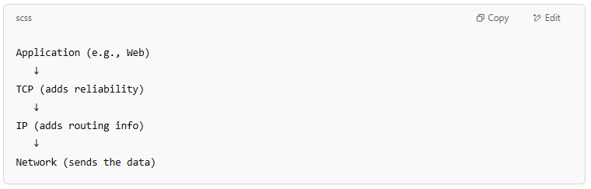
Application (e.g., Web)
↓
TCP (adds reliability)
↓
IP (adds routing info)
↓
Network (sends the data)

Examples of using TCP/IP Together
# Source: AI Source: Provided by: [Data Path: Persons Table -> ID Column: 1, Name_En Column: Motasem Essam] -> From: [ChatGPT] on [1/18/2026]
Here are real-world examples of how TCP/IP work together in daily internet activities:

✅ 1. Web Browsing (HTTP/HTTPS)

# Source: AI Source: Provided by: [Data Path: Persons Table -> ID Column: 1, Name_En Column: Motasem Essam] -> From: [ChatGPT] on [1/18/2026]
Example:
You visit https://www.example.com
How TCP/IP work:
- TCP: Breaks your request into packets, numbers them, ensures all are delivered and in the right order.
- IP: Sends each packet across the internet to the web server at example.com.
📦 TCP ensures the webpage loads completely and correctly
📍 IP ensures packets reach the right server

✅ 2. Sending Emails (SMTP, IMAP, POP)
# Source: AI Source: Provided by: [Data Path: Persons Table -> ID Column: 1, Name_En Column: Motasem Essam] -> From: [ChatGPT] on [1/18/2026]
Example:
You send an email using Gmail
How TCP/IP work:
- TCP: Makes sure the email content reaches Google's mail server without corruption.
- IP: Routes the packets to the correct mail server on the internet.
✉️ TCP guarantees the email is sent and received properly
📫 IP handles the routing from your device to the mail server

✅ 3. File Transfer (FTP or SFTP)
# Source: AI Source: Provided by: [Data Path: Persons Table -> ID Column: 1, Name_En Column: Motasem Essam] -> From: [ChatGPT] on [1/18/2026]
Example:
Uploading a file to a website using FTP
How TCP/IP work:
- TCP: Ensures every chunk of the file is transferred without loss or error.
- IP: Routes file data packets to the server hosting the site.
📂 TCP protects the file from being corrupted or incomplete
🌍 IP moves data to the target location

✅ 4. Video Calls (Zoom, Google Meet)
# Source: AI Source: Provided by: [Data Path: Persons Table -> ID Column: 1, Name_En Column: Motasem Essam] -> From: [ChatGPT] on [1/18/2026]
Example:
You're on a video call with a friend
How TCP/IP work:
- Some calls use TCP (for chat, login, signaling)
- Some use UDP (a faster, less reliable alternative) for video/audio
- IP still routes all packets (whether TCP or UDP)
🎥 TCP makes sure messages and file shares are accurate
🌐 IP ensures all parts of the conversation get routed correctly

✅ 5. Online Shopping
# Source: AI Source: Provided by: [Data Path: Persons Table -> ID Column: 1, Name_En Column: Motasem Essam] -> From: [ChatGPT] on [1/18/2026]
Example:
You buy something from Amazon
How TCP/IP work:
- TCP: Handles your login, payment info, and product requests securely and in order.
- IP: Makes sure the data travels to Amazon’s servers and back.
💳 TCP ensures your payment data is intact and secure
📬 IP gets that data to Amazon's data center

🔁 Summary
# Source: AI Source: Provided by: [Data Path: Persons Table -> ID Column: 1, Name_En Column: Motasem Essam] -> From: [ChatGPT] on [1/18/2026]
In all these examples:
- TCP = reliable delivery and error correction
- IP = addressing and routing across networks
Together, they ensure that data gets where it needs to go, safely and completely.

4-UDP

What is UDP (User Datagram Protocol)?
# Source: AI Source: Provided by: [Data Path: Persons Table -> ID Column: 1, Name_En Column: Motasem Essam] -> From: [ChatGPT] on [1/18/2026]
UDP is a communication protocol that sends data quickly without ensuring it arrives correctly or in order.

Key Features of UDP:
# Source: AI Source: Provided by: [Data Path: Persons Table -> ID Column: 1, Name_En Column: Motasem Essam] -> From: [ChatGPT] on [1/18/2026]
- Connectionless: No handshake or connection setup before sending data.
- No guarantee of delivery, order, or error correction.
- Very fast and lightweight, ideal for real-time communication.

Used For:
# Source: AI Source: Provided by: [Data Path: Persons Table -> ID Column: 1, Name_En Column: Motasem Essam] -> From: [ChatGPT] on [1/18/2026]
- Streaming video/audio (e.g., YouTube, Zoom)
- Online gaming
- Voice over IP (VoIP)
- DNS lookups

Datagrams
# Source: AI Source: Provided by: [Data Path: Persons Table -> ID Column: 1, Name_En Column: Motasem Essam] -> From: [ChatGPT] on [1/18/2026]
A datagram is a self-contained packet of data that is sent across a network without a connection and without guarantees of delivery, order, or reliability.

Key Features:
# Source: AI Source: Provided by: [Data Path: Persons Table -> ID Column: 1, Name_En Column: Motasem Essam] -> From: [ChatGPT] on [1/18/2026]
- Connectionless: No setup between sender and receiver.
- Sent independently — each datagram travels its own path.
- Used in protocols like UDP.
- May arrive out of order, duplicate, or not at all.

What's Inside a Datagram?
# Source: AI Source: Provided by: [Data Path: Persons Table -> ID Column: 1, Name_En Column: Motasem Essam] -> From: [ChatGPT] on [1/18/2026]
A typical datagram contains:
- Header – includes:
  - Source & destination IP addresses
  - Port numbers
  - Length & other info
- Payload – the actual data being sent

Analogy:
# Source: AI Source: Provided by: [Data Path: Persons Table -> ID Column: 1, Name_En Column: Motasem Essam] -> From: [ChatGPT] on [1/18/2026]
A datagram is like sending a postcard:
You write a message, drop it in the mailbox — no guarantee it arrives, or when.

Used In:
# Source: AI Source: Provided by: [Data Path: Persons Table -> ID Column: 1, Name_En Column: Motasem Essam] -> From: [ChatGPT] on [1/18/2026]
- UDP (User Datagram Protocol)
- IP (Internet Protocol)
- Real-time apps: video, voice, gaming

Summary
# Source: AI Source: Provided by: [Data Path: Persons Table -> ID Column: 1, Name_En Column: Motasem Essam] -> From: [ChatGPT] on [1/18/2026]
A datagram is a small, independent packet of data used in fast, connectionless communication — no guarantee it will be delivered or arrive in order.

How It Works:
# Source: AI Source: Provided by: [Data Path: Persons Table -> ID Column: 1, Name_En Column: Motasem Essam] -> From: [ChatGPT] on [1/18/2026]
- Data is sent in datagrams.
- The receiver may get packets:
  - Out of order
  - With errors
  - Or not at all — no retransmission

Analogy:
# Source: AI Source: Provided by: [Data Path: Persons Table -> ID Column: 1, Name_En Column: Motasem Essam] -> From: [ChatGPT] on [1/18/2026]
UDP is like sending postcards — you send them quickly, but you don’t know if they’ll arrive or arrive in order.

Comparison to TCP and UDP:
# Source: AI Source: Provided by: [Data Path: Persons Table -> ID Column: 1, Name_En Column: Motasem Essam] -> From: [ChatGPT] on [1/18/2026]

Feature | TCP | UDP
Reliability | High (acknowledgments, retransmits) | Low (no guarantees)
Speed | Slower (due to checks) | Faster
Connection | Requires handshake | No connection needed
Use Case | Web, email, file transfer | Streaming, gaming, voice calls

IP vs TCP vs UDP

1. IP (Internet Protocol)
# Source: AI Source: Provided by: [Data Path: Persons Table -> ID Column: 1, Name_En Column: Motasem Essam] -> From: [ChatGPT] on [1/18/2026]
- Role: Responsible for addressing and routing packets of data so they can travel across networks and reach the correct destination.
- Think of IP as the postal system that delivers mail by addresses.
- IP Address is like the device’s home address on the network.
- Versions: IPv4 (e.g., 192.168.0.1), IPv6 (newer, larger address space)

2. TCP (Transmission Control Protocol)
# Source: AI Source: Provided by: [Data Path: Persons Table -> ID Column: 1, Name_En Column: Motasem Essam] -> From: [ChatGPT] on [1/18/2026]
- Works on top of IP.
- Provides reliable, ordered, and error-checked delivery of data between applications.
- Think of TCP as a phone call where you confirm the message was received correctly.
- Ensures data arrives complete and in order (used for web pages, emails, file transfers).

3. UDP (User Datagram Protocol)
# Source: AI Source: Provided by: [Data Path: Persons Table -> ID Column: 1, Name_En Column: Motasem Essam] -> From: [ChatGPT] on [1/18/2026]
- Also works on top of IP.
- Provides a faster but less reliable way to send data.
- Think of UDP as sending a postcard — no guarantee it arrives, no acknowledgment.
- Used when speed is critical and some data loss is acceptable (e.g., video streaming, online gaming, VoIP).

Summary Table
# Source: AI Source: Provided by: [Data Path: Persons Table -> ID Column: 1, Name_En Column: Motasem Essam] -> From: [ChatGPT] on [1/18/2026]

Protocol | Main Function | Reliability | Use Cases
IP | Addressing and routing data packets | N/A | All internet communications
TCP | Reliable, ordered data transmission | Reliable, connection-oriented | Web browsing, email, file transfer
UDP | Fast, connectionless data transfer | Unreliable, no guarantee | Streaming, gaming, voice calls

Summary
# Source: AI Source: Provided by: [Data Path: Persons Table -> ID Column: 1, Name_En Column: Motasem Essam] -> From: [ChatGPT] on [1/18/2026]
IP routes packets to the right device.
TCP ensures reliable communication.
UDP prioritizes speed over reliability.

Summary
# Source: AI Source: Provided by: [Data Path: Persons Table -> ID Column: 1, Name_En Column: Motasem Essam] -> From: [ChatGPT] on [1/18/2026]
UDP is a fast, lightweight protocol used when speed matters more than reliability.

5-DHCP

🌐 What is DHCP?
# Source: AI Source: Provided by: [Data Path: Persons Table -> ID Column: 1, Name_En Column: Motasem Essam] -> From: [ChatGPT] on [1/18/2026]
DHCP stands for Dynamic Host Configuration Protocol. It is a network protocol used to automatically assign IP addresses and other network configuration settings (like DNS, gateway) to devices on a network.
🚀 Without DHCP, every device (laptop, phone, printer) would need to be manually configured to connect to the network.

🧠 How DHCP Works (Basic Flow)
# Source: AI Source: Provided by: [Data Path: Persons Table -> ID Column: 1, Name_En Column: Motasem Essam] -> From: [ChatGPT] on [1/18/2026]
- Device connects to network (e.g., Wi-Fi).
- It sends a DHCPDISCOVER request asking for an IP.
- The DHCP Server responds with an IP and other settings.
- The device accepts the offer and configures itself.
- Done! The device is now online.

🔄 DHCP Process in Steps
# Source: AI Source: Provided by: [Data Path: Persons Table -> ID Column: 1, Name_En Column: Motasem Essam] -> From: [ChatGPT] on [1/18/2026]
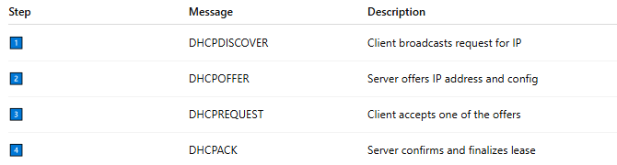
Step | Message | Description
1️⃣ | DHCPDISCOVER | Client broadcasts request for IP
2️⃣ | DHCPOFFER | Server offers IP address and config
3️⃣ | DHCPREQUEST | Client accepts one of the offers
4️⃣ | DHCPACK | Server confirms and finalizes lease

🏢 Why Use DHCP?
# Source: AI Source: Provided by: [Data Path: Persons Table -> ID Column: 1, Name_En Column: Motasem Essam] -> From: [ChatGPT] on [1/18/2026]
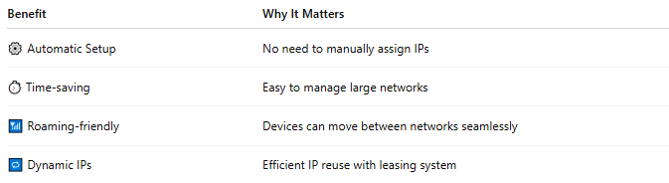
Benefit | Why It Matters
⚙️ Automatic Setup | No need to manually assign IPs
⏱️ Time-saving | Easy to manage large networks
📶 Roaming-friendly | Devices can move between networks seamlessly
🔁 Dynamic IPs | Efficient IP reuse with leasing system

📦 What DHCP Provides (Besides IP Address)
# Source: AI Source: Provided by: [Data Path: Persons Table -> ID Column: 1, Name_En Column: Motasem Essam] -> From: [ChatGPT] on [1/18/2026]
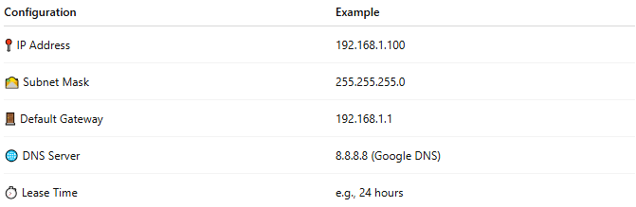
Configuration | Example
📍 IP Address | 192.168.1.100
🛣️ Subnet Mask | 255.255.255.0
🚪 Default Gateway | 192.168.1.1
🌐 DNS Server | 8.8.8.8 (Google DNS)
⏱️ Lease Time | e.g., 24 hours

🖥️ Where DHCP Is Used
# Source: AI Source: Provided by: [Data Path: Persons Table -> ID Column: 1, Name_En Column: Motasem Essam] -> From: [ChatGPT] on [1/18/2026]
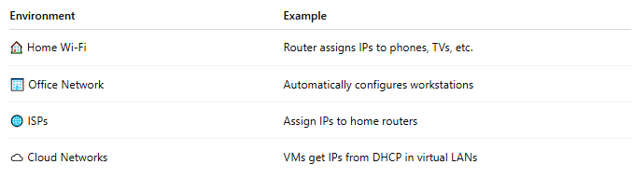
Environment | Example
🏠 Home Wi-Fi | Router assigns IPs to phones, TVs, etc.
🏢 Office Network | Automatically configures workstations
🌐 ISPs | Assign IPs to home routers
☁️ Cloud Networks | VMs get IPs from DHCP in virtual LANs

✅ Summary
# Source: AI Source: Provided by: [Data Path: Persons Table -> ID Column: 1, Name_En Column: Motasem Essam] -> From: [ChatGPT] on [1/18/2026]

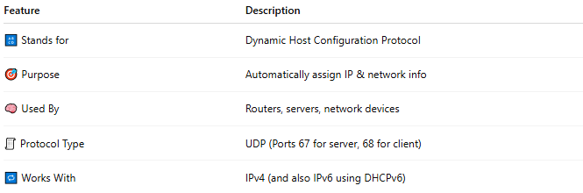
Feature | Description
🔠 Stands for | Dynamic Host Configuration Protocol
🎯 Purpose | Automatically assign IP & network info
🧠 Used By | Routers, servers, network devices
🧾 Protocol Type | UDP (Ports 67 for server, 68 for client)
🔁 Works With | IPv4 (and also IPv6 using DHCPv6)

